EXPERIMENT- 29
Morphological Operations based on OpenCV using Erosion Technique
Aim
To write a Python code to perform erosion morphological operation using OpenCV for removing small white noises and shrinking object boundaries.
Input Image
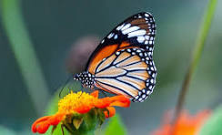
Code
import cv2
import numpy as np
from google.colab.patches import cv2_imshow
from google.colab import files
uploaded=files.upload()
image_path=list(uploaded.keys())[0]
image=cv2.imread(image_path,cv2.IMREAD_GRAYSCALE)
if image is None:
print("Error: Image not found")
else:
kernel=np.ones((5,5),np.uint8)
erosion_result=cv2.erode(image,kernel,iterations=1)
print("Original Image")
cv2_imshow(image)
print("Erosion Result")
cv2_imshow(erosion_result)
Output Image
Erosion Result
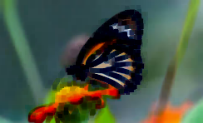
Result
Thus, erosion morphological operation was successfully performed using OpenCV.

